Content

Search Space & Rejected Solutions 3

Analysis 4

Evite 5

Create Business type Invitations 5

Create a Design from Scratch 6

Upload our logo on Invite 8

Upload Addresses from .csv 10

Invitees’ Experience 11

Track Responses 14

Auto Thank you or Confirmation Email 16

Send auto Reminders 17

Export Names to .csv 18

Add new Guests 19

Paperless Post 20

Create Business type Invitations 20

Create a Design from Scratch 21

Upload our logo on Invite (3 Coins) 22

Extra: Add an Envelope (2 Coins) 23

Upload Addresses from .csv 25

Invitees’ Experience 26

Track Responses 28

Auto Thank you or Confirmation Email 29

Send auto Reminder 30

Export names to .csv 31

Add new Guests 32

Punchbowl 33

Create Business type Invitations 33

Create a Design from Scratch 34

Upload our logo on Invite 35

Upload Addresses from .csv 36

Invitees’ Experience 37

Track Responses 39

Auto Thank you or Confirmation Email 43

Send auto Reminder 44

Export names to .csv 46

Add new Guests 47

# Search Space & Rejected Solutions

This [website](https://www.whatsontech.com/evite-alternatives/), suggested by Debbie, was the main origin for research and coming up with recommendations, however other sources were checked too. **Greenenvelope** and **Eventbrite** were evaluated but did not make it to the list. A visual guide for both websites was created, however, upon observing a few features that were not ideal for our needs, I had to remove them from the list. Greenenvelope is a highly user-friendly website with fantastic designs, and it matches all of requirements, however, after doing research, they charge $424 for a single event with 500 people, which is very expensive, and so I had to remove them from the list. Eventbrite meets most of our requirements and it is free of charge for free events, however, it is designed for ticketing and not for sending invitations, therefore, it does not have any custom designs to make a good impression for invitees.

# Analysis

|  |  |  |  |
| --- | --- | --- | --- |
|  | Evite | Paperless Post | Punchbowl |
| Business type invitation | Yes | Yes | Yes (Professional is what it is called) |
| Put our own logo on invite | Yes | Yes | Yes (For some designs only) |
| Create from blank | Yes | Yes | Yes |
| Upload addresses from .csv file | Yes | Yes | Yes |
| Track responses | Yes | Yes | Yes |
| Send auto reminders | Yes | Yes | Yes |
| Send auto thank you email | Yes | Yes | Yes |
| Send location of event | Yes | Yes | Yes |
| Pricing | Basic - Free  Premium - $14.99 -$79.99 /Event   * Small (15 guests): $14.99. * Medium (40 guests): $29.99. * Large (100 guests): $59.99. * Extra Large (750 guests): $79.99.   Pro - $249.99/Yearly Subscription | * All Cards: Free or Premium 2 Coins * Any Envelope, Liner, Backdrop, Stamp, Reply Card: 1 Coin * Upload-your-Logo: 3 Coins   Total Coins needed to send to your guest list is the total Coin price of your design multiplied by the number of cards sent. Considering you have (500 guests) * (5 coins) = 2500 coins. Each 1000 coins is $100 US. So, $250 US for an event. | $95.88 per year or $34.99 per month, to remove advertising and up to 500 guests. |
| Export attendees’ names to .csv file | Yes | Yes | Yes |
| Could be up to 500 people | Yes | Yes | Yes |

# Evite

## Create Business type Invitations

Visit this [link](https://www.evite.com/gallery/category/professional_events/1?source_sidenav&filter=invitation&) to view Professional Event invitations.

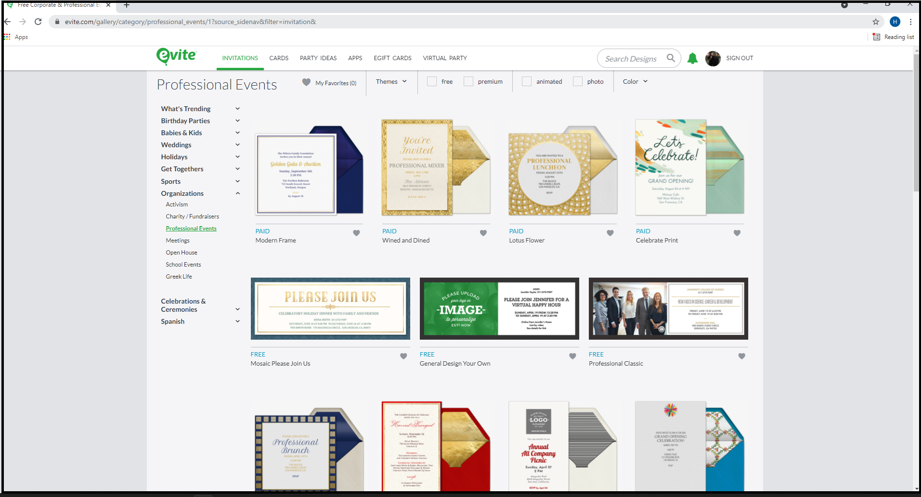

Or follow this [link](https://www.evite.com/plus/create/start/design-own-portrait-1/?v=design-own-portrait-1&c=design_your_own) to create a design from scratch.

In either case, we can upload our own branding. Also, we can have an envelope and the stamp on that envelope can be uploaded.



## Create a Design from Scratch

Generally, custom designs are not free. However, there are some of them that are free. Let’s use a free custom design template to get started. We are not going to upload our logo in this case because we want to create a free invitation.

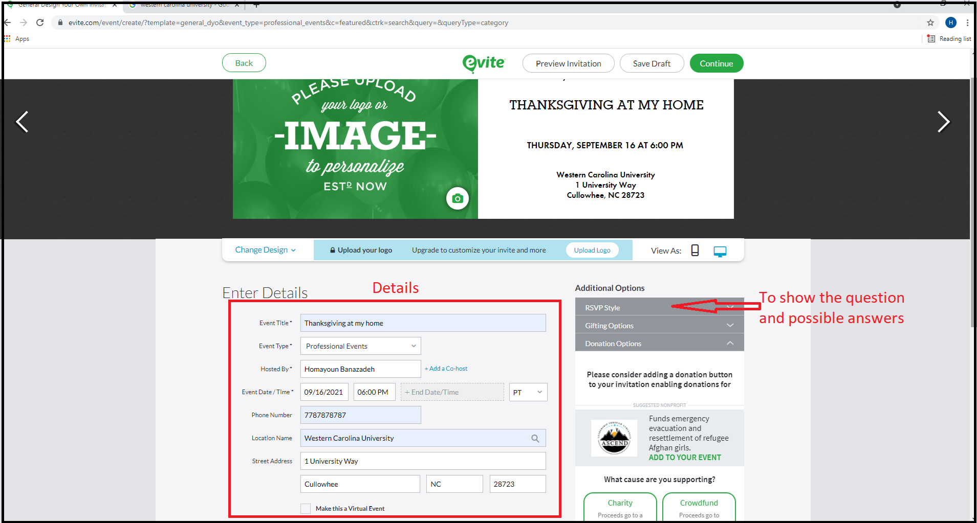

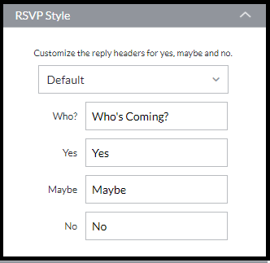

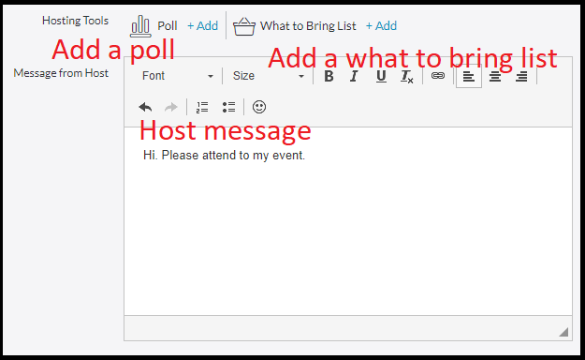

## Upload our logo on Invite

This is a paid feature so I cannot do it on my demo but here is how it is done based on their website.

- On Step 1, click the "Branding" tab on the left.

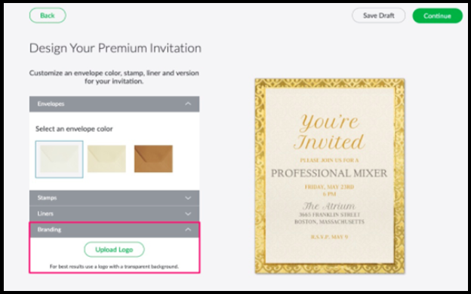

- Click the "Upload Logo" button  
- Choose and upload your logo (logos with transparent backgrounds are the best to use)  
- After uploading your logo, you may drag it to any location on your invitation. You may also use the "Remove Logo" button to remove the logo.

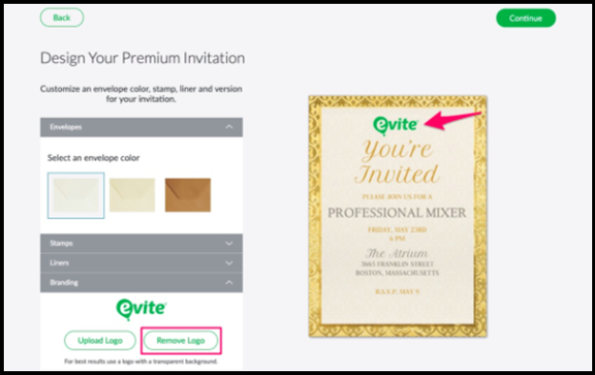

- Click the "Continue" button to proceed and complete your invitation.

## Upload Addresses from .csv

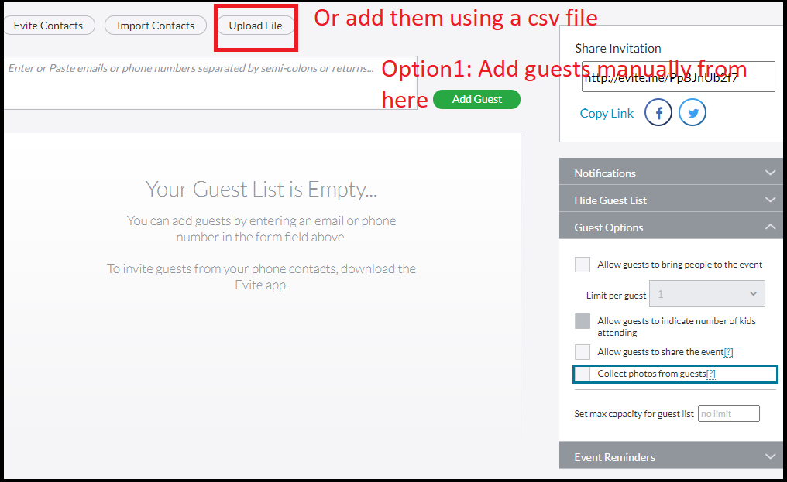

## Invitees’ Experience

As an invitee, I do not get to see the full invite in my email. Here is what I see in the email. In the following menu, the guest list, their status, and RSVP comments are available. I can click on View Invitation to view more details.

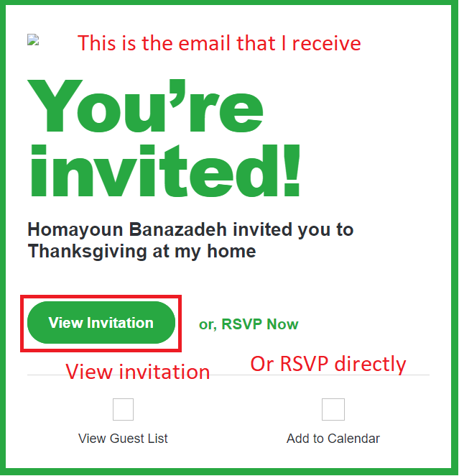

After that. I go to Evite’s website and see the invitation card, and I can RSVP to it. Here is the example card.

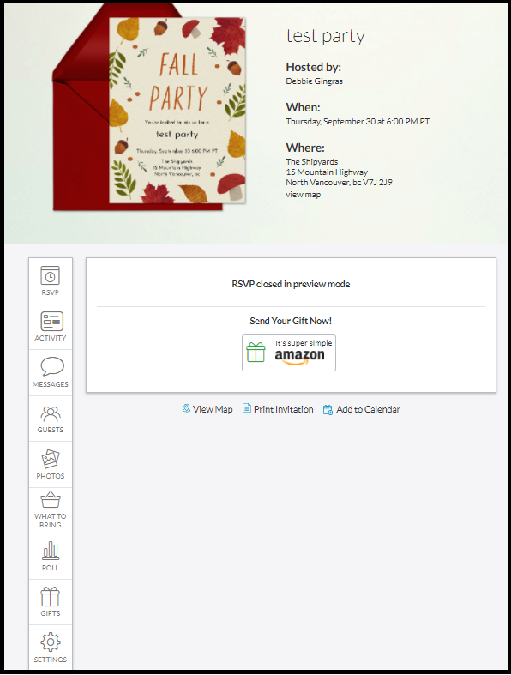

 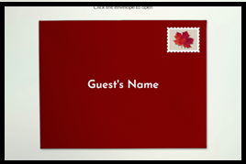

## Track Responses

From the main events menu, select More button and click on Manage Invitations.

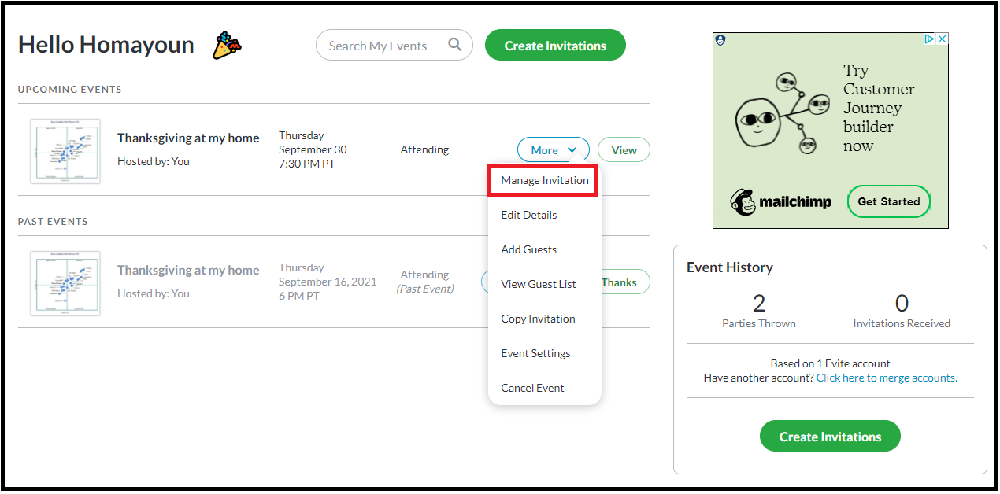

In this menu, I can see some information about the attendees, such as their name, email address, status, and I can message them as well. If I click in View Invitation, I can see more details about what to bring list and comments they have made.

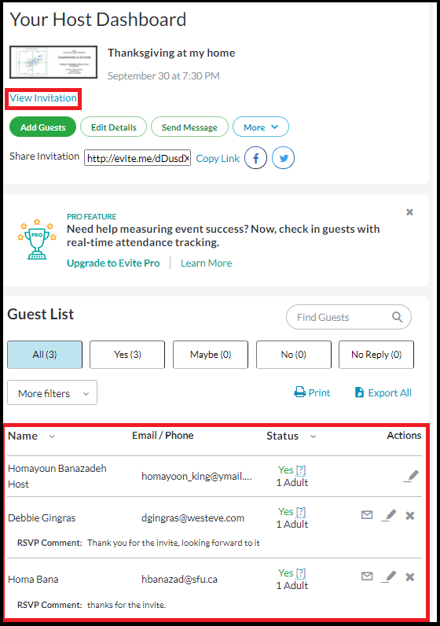

## Auto Thank you or Confirmation Email

I receive a thank you letter when I send my RSVP.

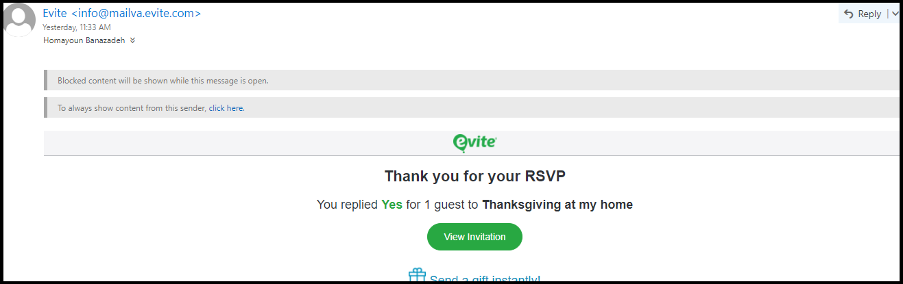

## Send auto Reminders

When creating the event, the host can set auto reminders, so the invitees receive a notification email a few days before. Up to 2 reminders can be added.

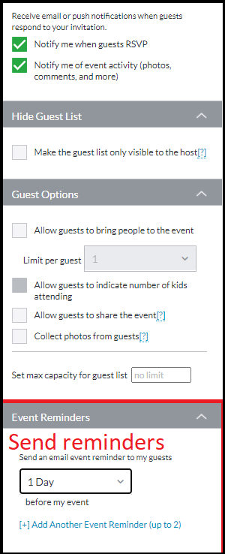

## Export Names to .csv

From the Event Management page, I can select Export All to export the information such as names, emails, and status into a .csv file.

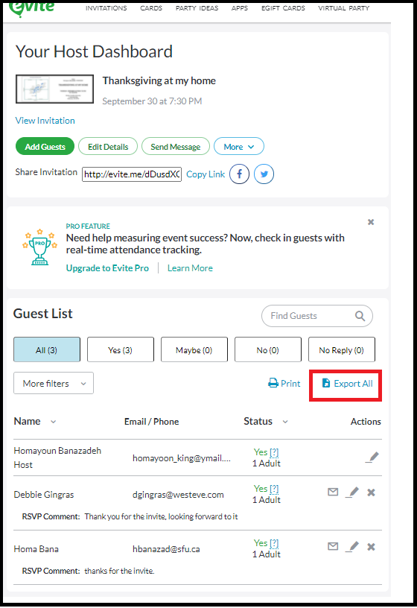

## Add new Guests

To add new guests, in Event Management page I can click on Add Guests.

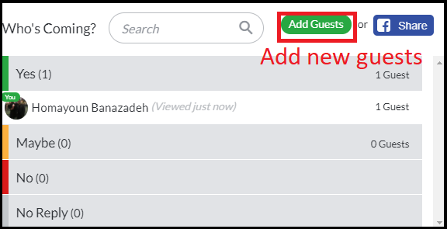

# Paperless Post

## Create Business type Invitations

Visit this [link](https://www.paperlesspost.com/cards/category/business-holiday-invitations) to see their business holiday invitations.

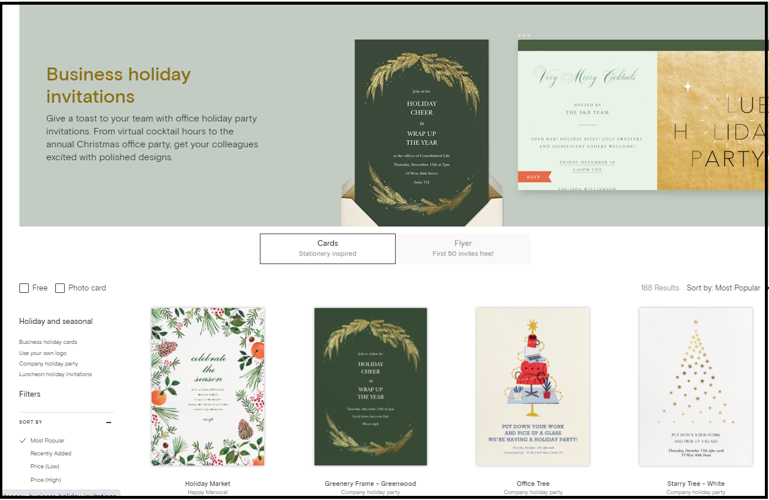

## Create a Design from Scratch

To create or upload our own design, visit this [link](https://www.paperlesspost.com/cards/category/upload-your-own-invitations). For this demo, let’s get a free design and start it. Different features cost coins in Paperless Post, and depending on how many guests you may have, the number of coins for a single card are multiplied by the number of guests to calculate total coins needed. Backdrop costs 1 coin, so I am going to remove it and click next.

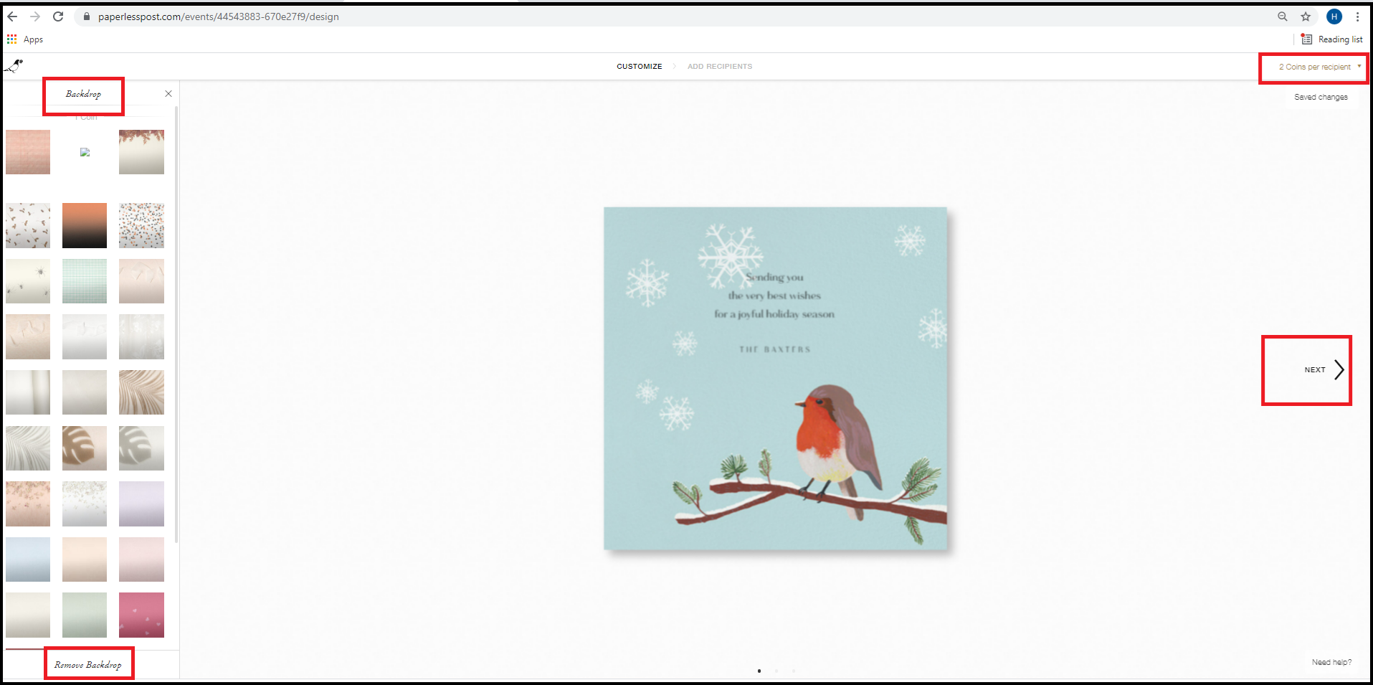

## Upload our logo on Invite (3 Coins)

In this page, we can write our custom message on the card, add our banner for the cost of 3 coins or add backdrop. I am going to remove the logo because we want the free features for this demo.

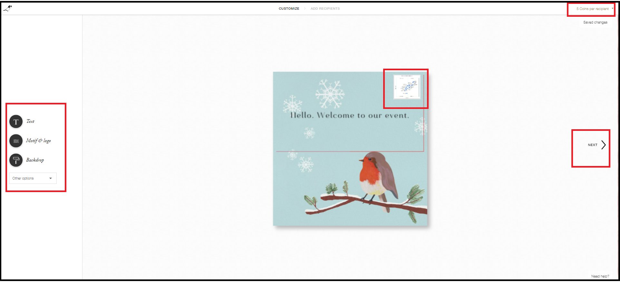

## Extra: Add an Envelope (2 Coins)

In this page, we can add an envelope with liners and backdrop, but it is going to cost 2 coins. Click on other options and remove it.

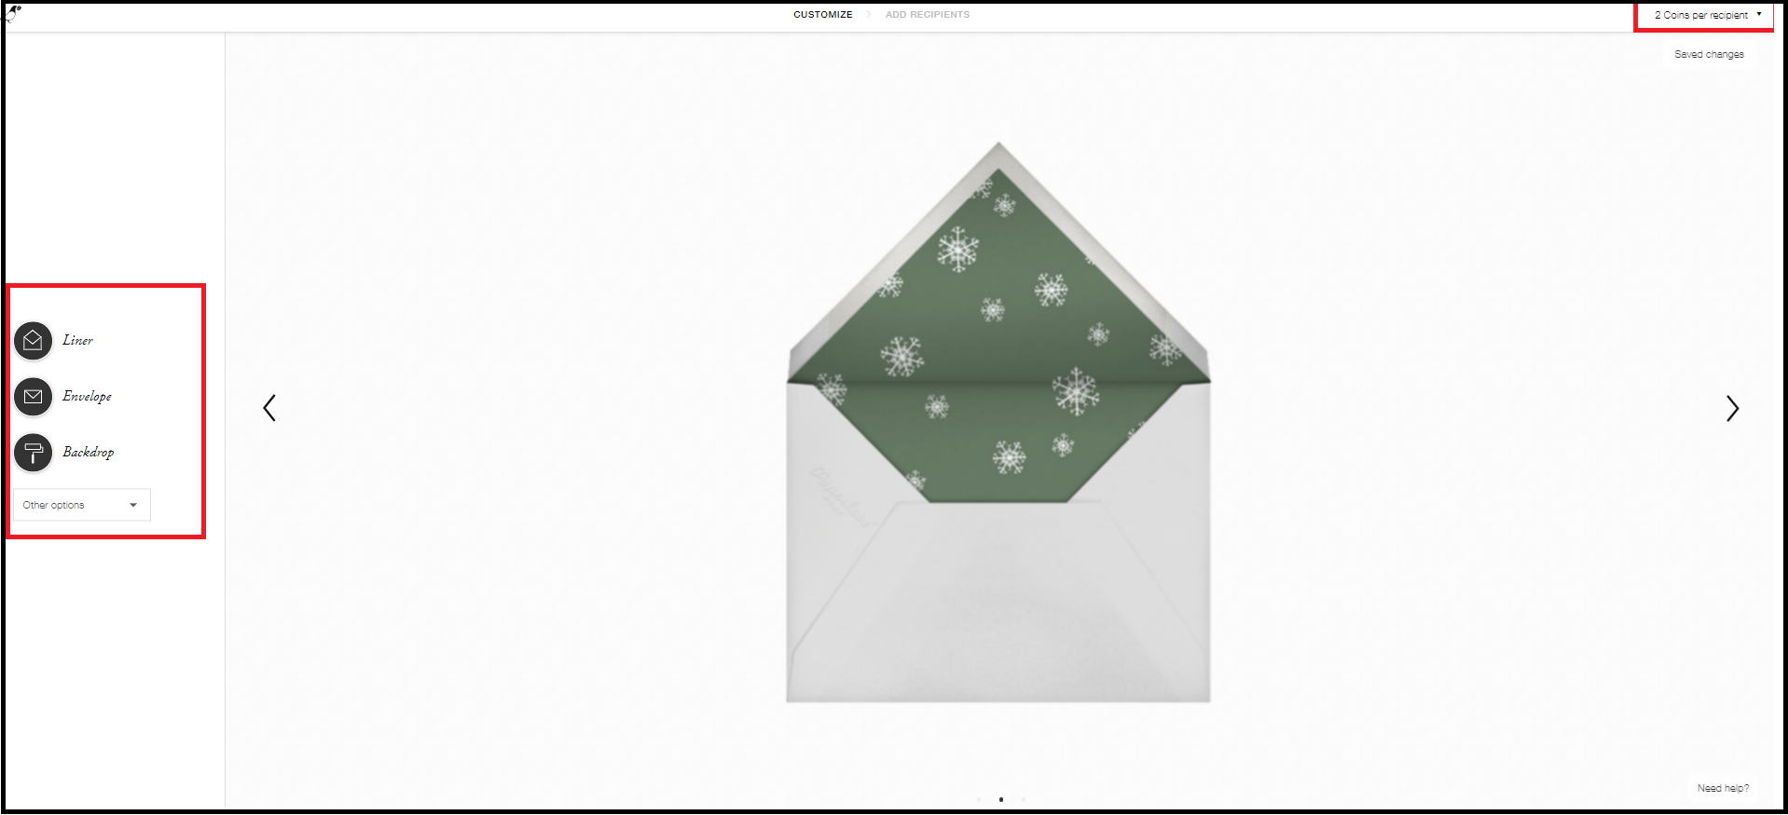

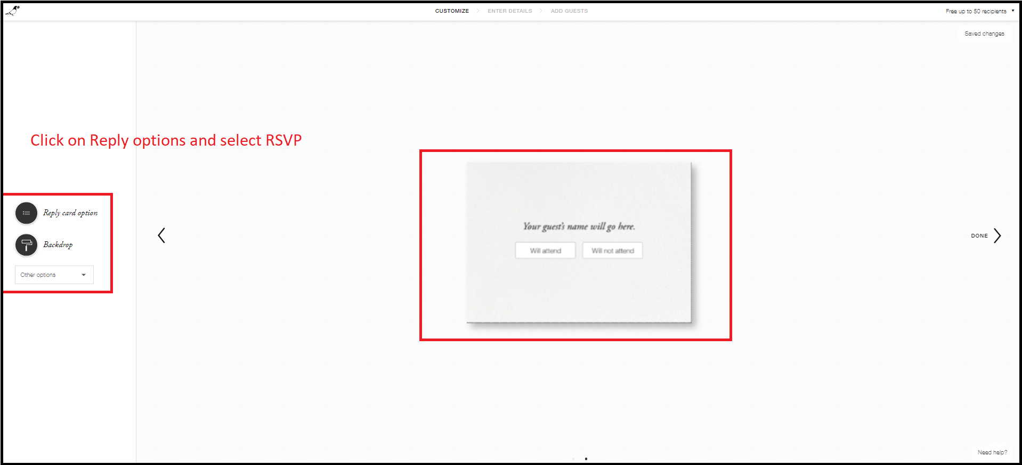

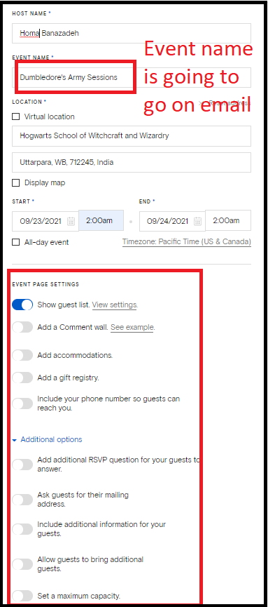

Upload Addresses from .csv

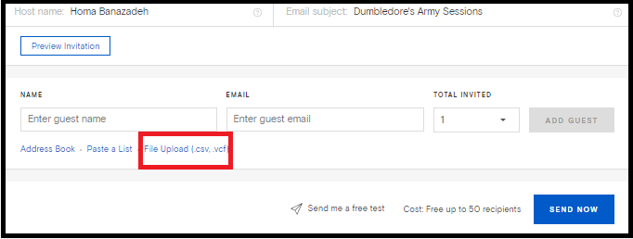

## Invitees’ Experience

This is the email that I receive with the invitation

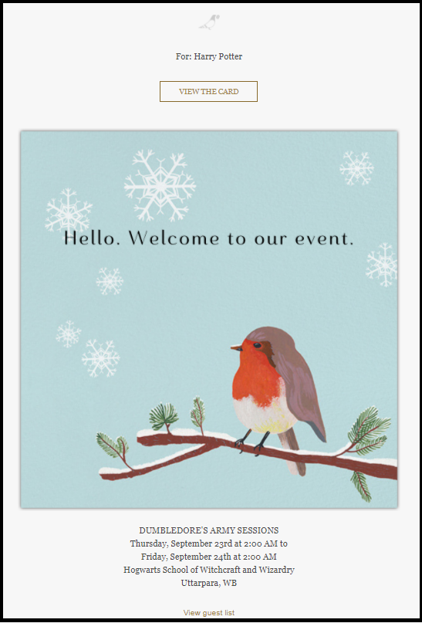

I can click on the card to come to their website and RSVP.

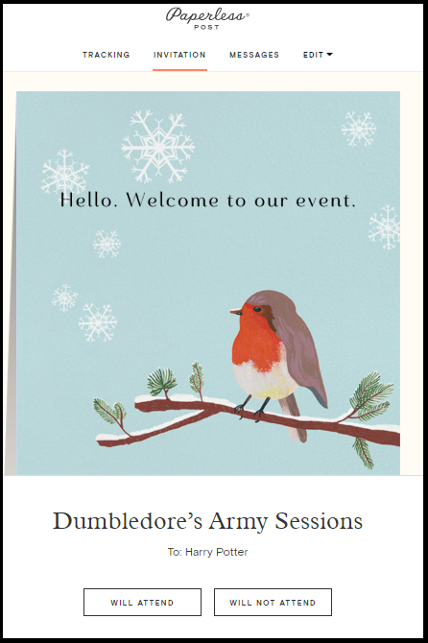

## Track Responses

Visit this link and click on Manage to be redirected to your event management.

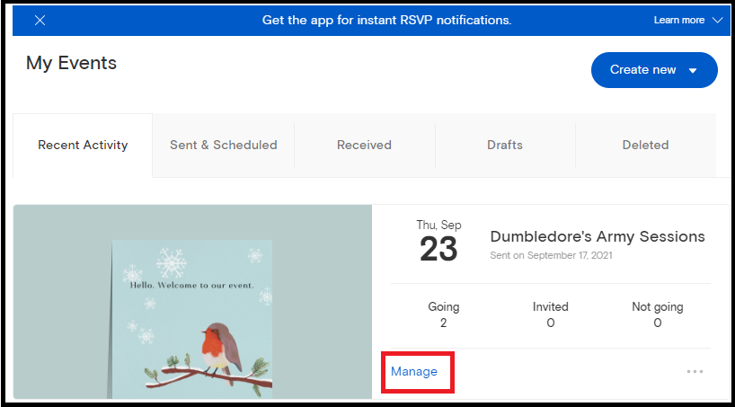

In event management, I will be able to send RSVP notifications, schedule an event reminder, send a message to guests, and see the status of attendees.

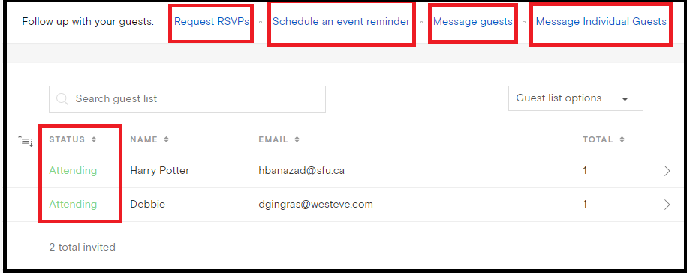

## Auto Thank you or Confirmation Email

After RSVP, I receive an email confirming that I will attend with some options to add it to my calendar and update my reply.

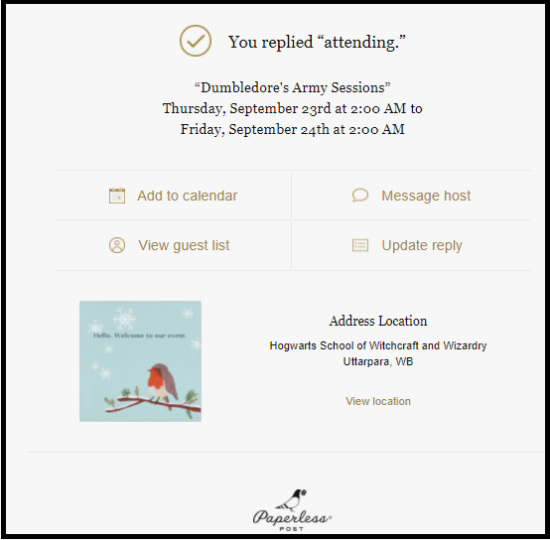

## Send auto Reminder

In event management page, I can click on Schedule an event reminder to set it up.

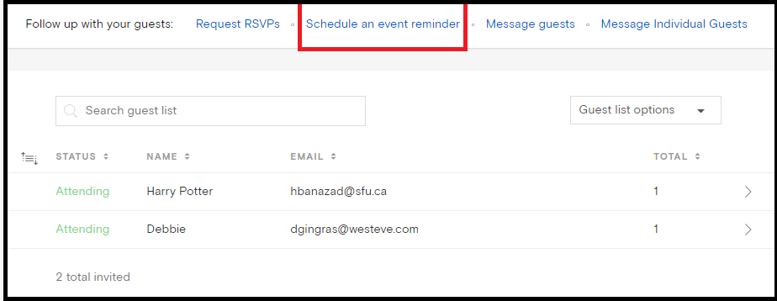

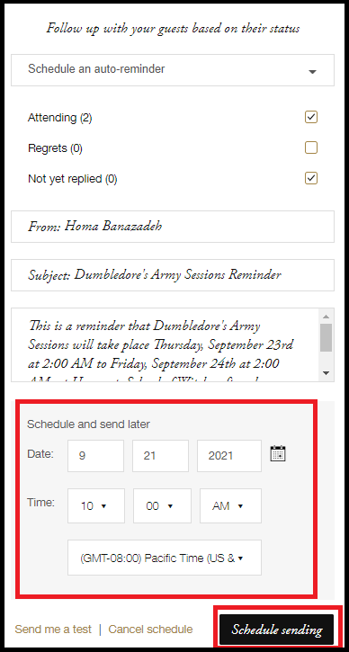

## Export names to .csv

In event management menu, hover over Guest list options, and click on Export list to get a .csv of guests and their attendance status.

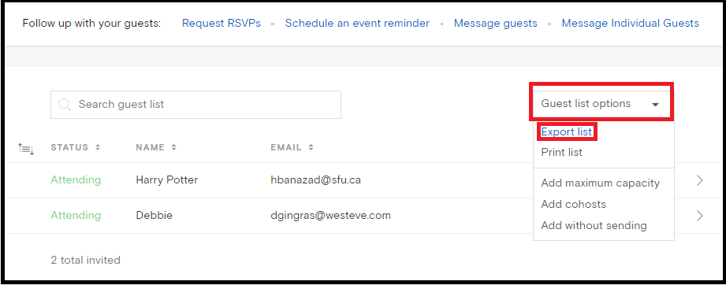

## Add new Guests

In event management menu, click on Add new guests.

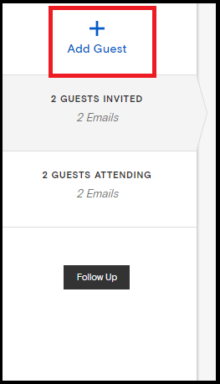

# Punchbowl

## Create Business type Invitations

Visit this [link](https://www.punchbowl.com/invitations/category/professional) to view their professional invitations.

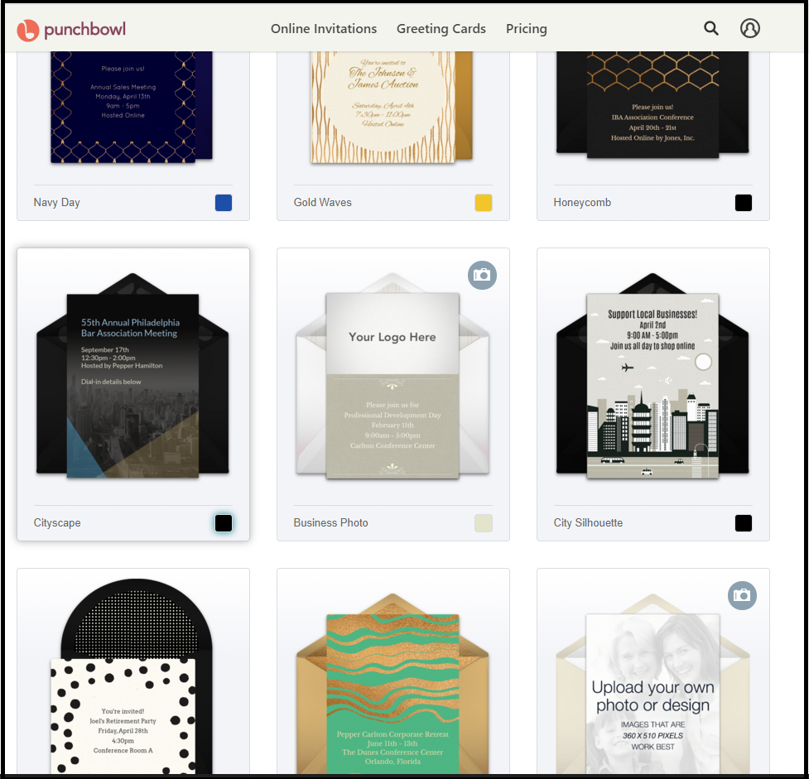

## Create a Design from Scratch

I can upload my own design from [here](https://www.punchbowl.com/invitations/preview/56732aef24e4b3655e000001/56732ef4196c6f210d0001dc). However, let’s pick a design from their gallery and get it started.

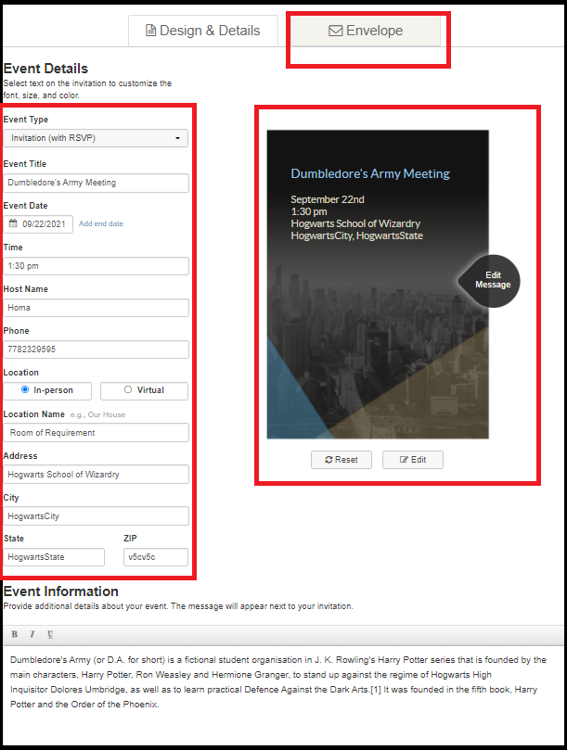

## Upload our logo on Invite

Note that only some designs allow for adding our own logo. Make sure to build the design from scratch or choose a design that comes with this capability.

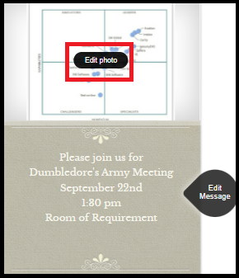

## Upload Addresses from .csv

In next page, click on Import Contacts, and from there, download the sample .csv file and upload it back. Now, the contact names should be added to the table.

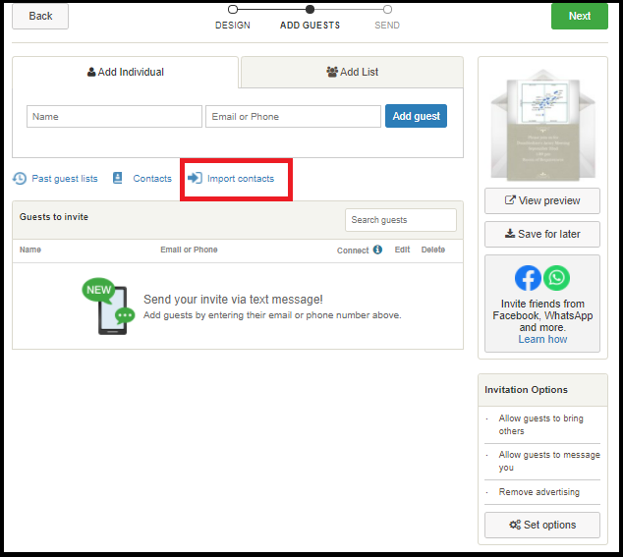

## Invitees’ Experience

After adding the guest list, when I click the send button, here is what happens. The invitee will receive an invitation email with the envelope and once they click on it, they are directed to Punchbowl’s website where they see an animation of the envelope opening and showing the invitation card. That is where they can RSVP to it.

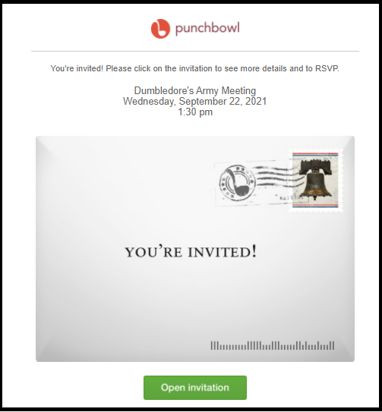

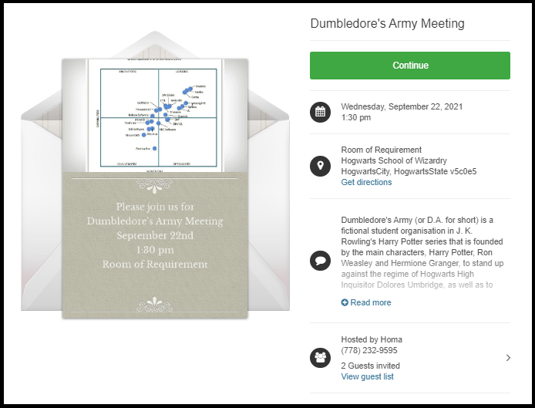

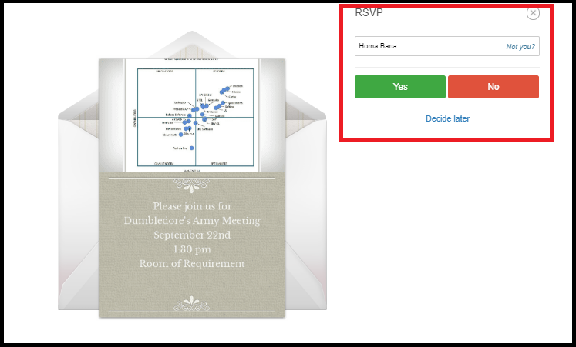

## Track Responses

To enable the capability for event management, please click on Set Options button and adjust the Show Guest List menu as below.

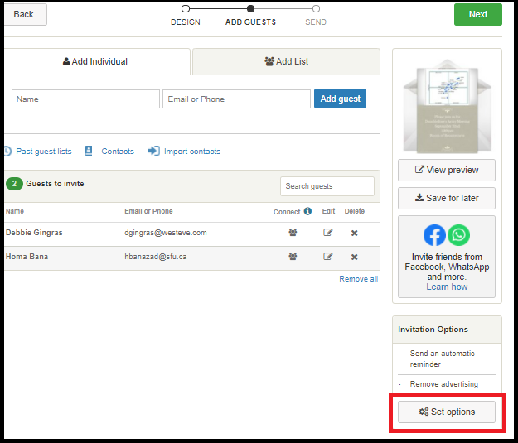

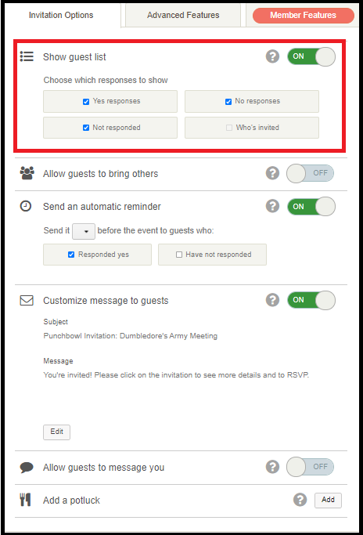

As a host, I visit my dashboard and click on Manage Invitation on my event.

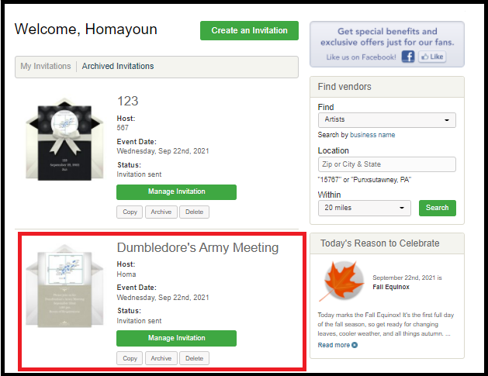

In next menu, I can view and manage my invitations.

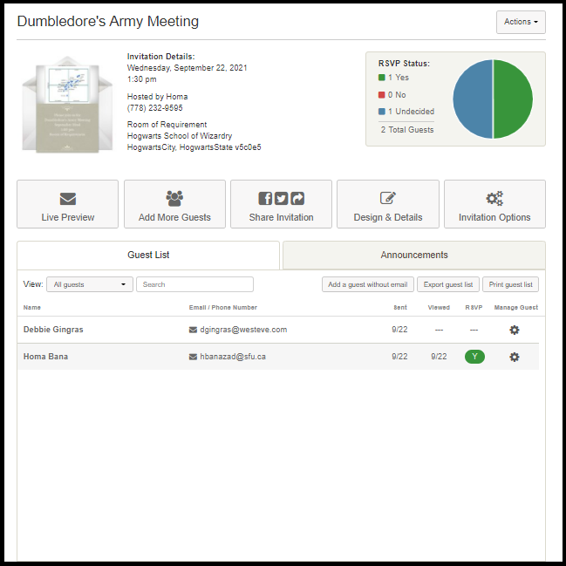

## Auto Thank you or Confirmation Email

As an invitee, once I do the RSVP, I receive a confirmation email.

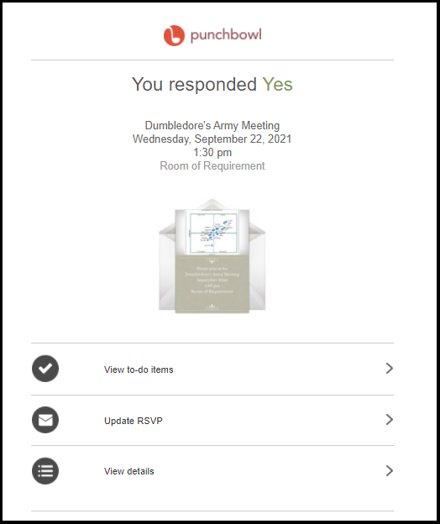

## Send auto Reminder

When creating the event, click on Set Options menu to set up auto reminders.



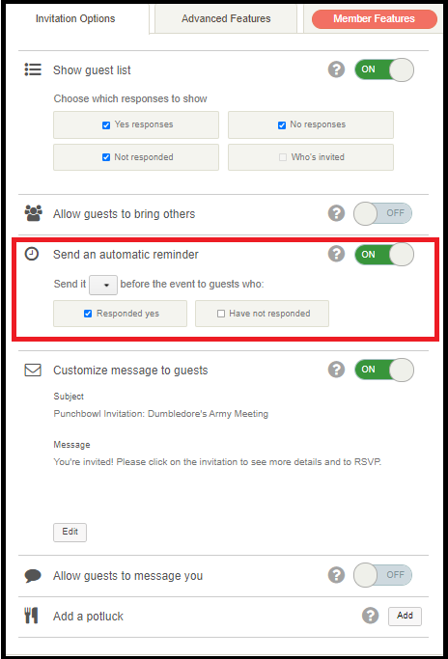

## Export names to .csv

In event management page, click on Export guest list to get a .csv file of all the guests and their attending status.

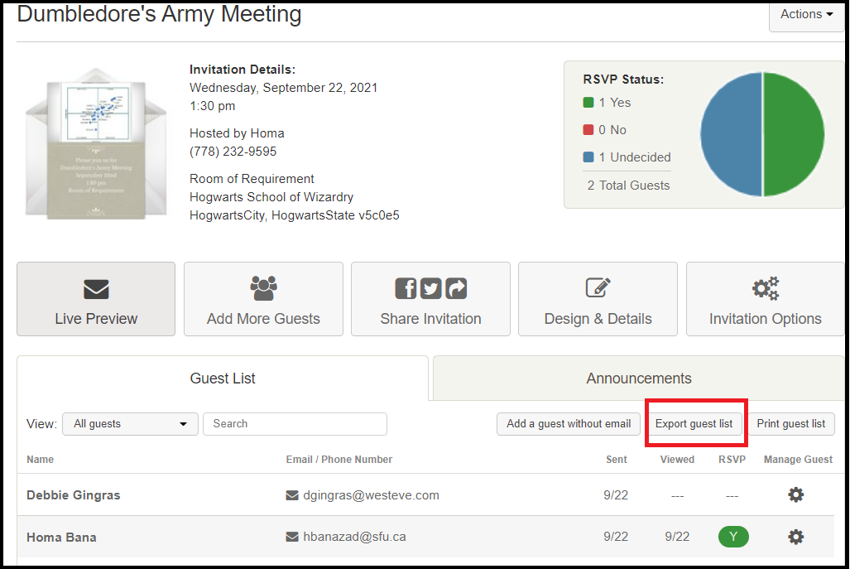

## Add new Guests

In event management page, click on Add More Guests.

